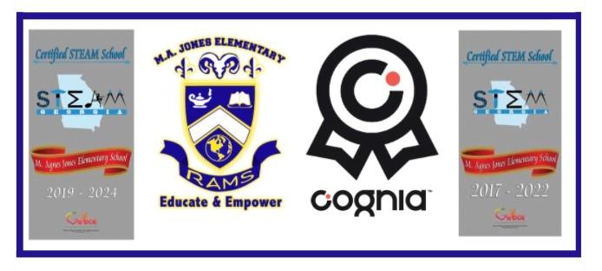

**M. Agnes Jones Elementary School**

**Quarantined Scholars**

**Virtual Instructional Plan 2022-2023**

This Virtual Instructional Learning Plan outlines our process for continuing instruction in a virtual setting. In this plan we will consider a whole class or individual quarantine.

|  |  |
| --- | --- |
| **Whole Class Quarantine** | **Individual Quarantine** |
| An entire class is quarantined due to COVID Cases/Exposure (including Teacher) | One or more students test positive (unrelated cases) or one or more students test positive for COVID with exposure to other students within the classroom/team or grade level |

The on-line tools and options below will be available if there is a whole class or individual quarantine.

**Quarantined/Isolated Scholars:**

* Once your scholar has been quarantined/isolated, Ms. Rutledge, our Assistant Principal, will email your scholar’s homeroom teacher who will contact you within 24 hours to share the following information:
  + The best time for Chromebook or iPad pick-up (if your scholar does not already have an assigned device from the school)
  + Where and how to complete assignments in Google Classroom

**Internet Access: **

* If you need a hotspot to access the internet, please contact the school’s technology contact, Mrs. McGhee at 404-802-3907. She will put in a ticket for a hotspot for you. There is only one hotspot per household.

\**Please note*: If your scholar is sick and unable to complete the assignments, additional time will be allowed to complete assignments once he/she is feeling better. Please be sure to contact the child’s teacher and/or the main office at 404-802-3900 if your child is ill.

**Assignments:**

Your scholar’s teachers will list the directions for assignments and any resources needed to complete the assignments in Google Classroom including supporting videos and links so your scholar has full access and necessary support to complete assignments with quality. 

**Academic apps**: 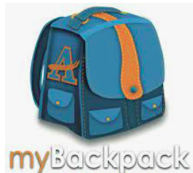

Although there are multiple apps provided in MyBackpack, our teachers will most likely use the identified apps below, as they allow your scholar to access instructional videos/lessons prior to completing assignments:

* Nearpod
* Social Studies Weekly
* Kids A-Z

**Please note**: To ensure the continuation of ESOL and Special Education services, Ms. Wiley (ESOL) and Mr. Farrington (Special Education Lead Teacher) will also be notified and be in contact with you. Ms. Rutledge (Assistant Principal) will contact teachers of quarantined student (s). The teacher will then contact parents and upload assignments and resources in Google Classroom.

*\*Specials:*

* Specials teachers will post assignments, videos and links for scholars in Google Classroom (No Zoom).

*Assignments*:

* If your scholar has not completed assignments in Google Classroom within 3 days, the teacher will contact you for your assistance. If your scholar needs additional support, please contact your scholar’s teacher.
* If your scholar is quarantined/isolated for more than 5 school days, the teacher will check in with the scholar and parent (phone/Zoom) to provide any assistance needed.

**Whole Class Quarantine**

In the event the entire class must quarantine/isolate due to COVID-19 exposure or infection the plan below outlines information if an entire class must quarantine. The times to log in for Literacy (SFA and Reading) will follow same schedule during a regular school day.

**Virtual Instruction for Quarantined Scholars:**

**Pre-K:**

Pre-K scholars will use the Seesaw platform in MyBackpack for virtual learning.

**K-5:**

K-5 scholars will use Zoom for instruction during Literacy and Math instruction.

* Your scholar’s homeroom teacher will schedule a Zoom meeting and place the link in Google Classroom at the top of the page in the “Classwork” tab.
* Scholars will log into Zoom for live instruction during whole group Literacy (SFA/Reading) and whole group Math instruction *daily*. Teachers will set up a time with your scholar to log in on Zoom for Science and Social Studies live instruction *one day per week*.
  + Below is a link to additional parent directions for how to log in to Zoom if parents have trouble accessing the link in Google Classroom: <http://tinyaps.com/?parent>

*\*Special Education and ESOL:*

* Special Education and ESOL teachers will access your scholar’s homeroom teacher’s Zoom link to join a breakout room with individual or small groups of scholars. This will allow them to provide services as needed. Or, the special education or ESOL teacher will set up a time with the parent to provide services needed.

\**Zoom*:

* If your scholar is not logging in on Zoom for live instruction, a conference with you and the teacher will be scheduled so that we can partner on the best way to support your child.

**Individual Quarantine**

In the event that one or more students have to quarantine instead of the entire class, teachers will post assignments on Google Classroom. A link to Zoom will be posted in the teacher’s Google Classroom with videos and assignments. Teacher tutors will be available Monday through Friday from 11am - 1pm to assist students on-line using a Zoom link on Google Classroom.



**Virtual Instruction for Quarantined Scholars:**

**Pre-K:**

Pre-K scholars will use the Seesaw platform in MyBackpack for virtual learning.

**K-5:**

K-5 scholars will use Zoom for instruction during Literacy and Math instruction.

* Your scholar’s homeroom teacher will post work in the “Classwork” tab in Google Classroom.
  + Below is a link to additional parent directions for how to log in to Zoom if parents have trouble accessing the link in Google Classroom: <http://tinyaps.com/?parent>

*\*Special Education and ESOL:*

* Special Education and ESOL teachers will access your scholar’s homeroom teacher’s Google Classroom to view assignments. This will allow teachers to provide services as needed. Or, the special education or ESOL teacher will set up a time with the parent to provide services needed.

If you have any questions, please contact Ms. Rutledge (assistant principal) at 404-802-3908.